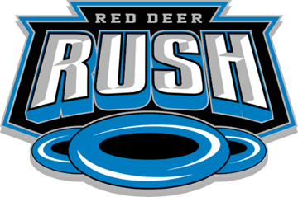

**2025-2026 EXECUTIVE NOMINATION FORM**

We, the undersigned, being members Red Deer Ringette Association of Alberta, hereby nominate:

**NAME OF NOMINEE**: _________________________________________________

**TO THE POSITION OF**

☐ PRESIDENT

**I ACCEPT NOMINATION**: __________________________________

(Signature of Nominee)

__________________________________

(Date)

| **Nominator 1:** | **Nominator 2:** |
| --- | --- |
| Name: | Name: |
| Signature:  ____________________________ | Signature:  _______________________________ |